
IP Communications Applications for Business Advantage

Metreos PCap Service
Administration Guide
Metreos Communications Environment 2.1

Copyright © 2005 Metreos Corporation
All Rights Reserved

Proprietary and Confidential
For Release under NDA Only

Configuring the PCAP Service
The PCAP network monitoring service must be configured to listen to a single network interface.

Two steps are required in order to configure the PCap Service to begin monitoring a specific network adapter.

1. Choose a Network Interface to Monitor

In a command window, execute C:\Metreos\PCapService\pcap-service.exe –N

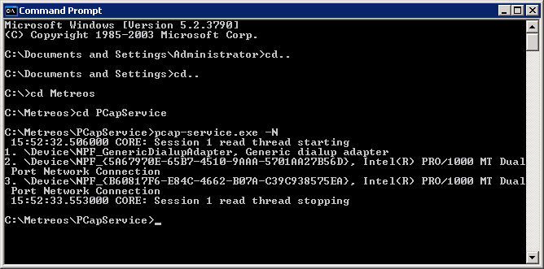
Figure 1: Discovering System Network Adapters

In the sample output shown in Figure 1, above, note that the PC is aware of 3 network adapters. We are not concerned with the Generic dialup adapter. If we were to physically look at the back of the server, the #2 adapter corresponds to the network adapter located on the left, and the #3 adapter corresponds to one on the right.

2. Configure the Network Adapter

With the network adapter you chose above to monitor the span port in mind, open the text file C:\Metreos\PCapService\pcap-service.config, and configure ETHERNET_INTERFACE_ID to the sequence number shown for the desired network adapter, as illustrated in the example shown in Figure 2.

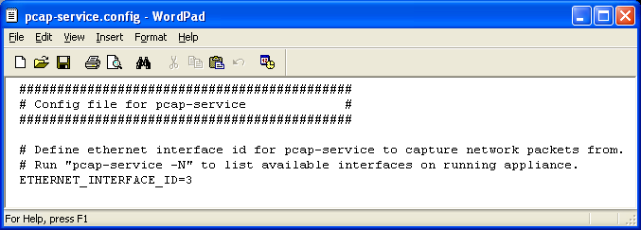
Figure 2: The PCAP Configuration File

If at any time the configuration is changed, the PCap Service will need to be restarted through the Metreos Web Management Console, mceadmin. The Service Control page found there, as shown in Figure 3, lets you restart this service easily. The service is labeled ‘PCap Service’.

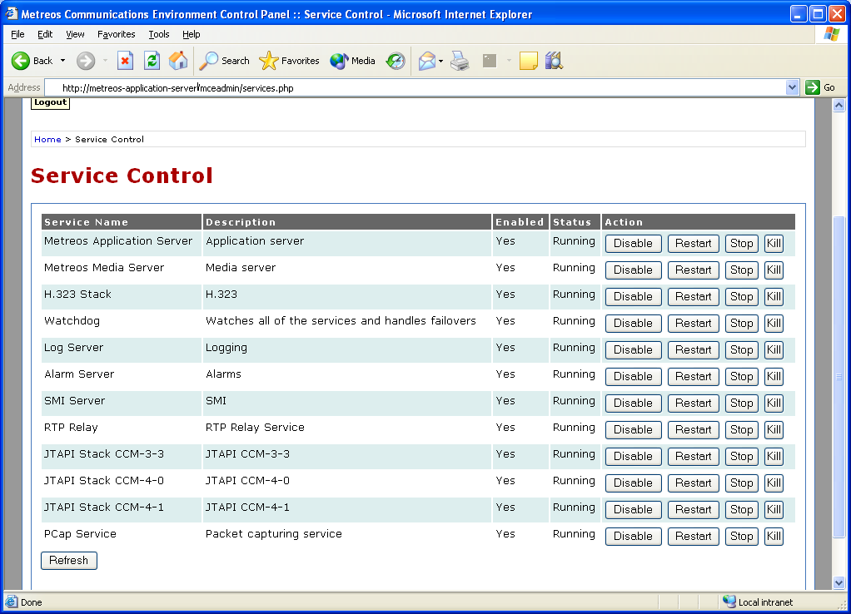
Figure 3: Service Control Panel

